Content | Asset
Celebrate 211 Day!  Every day, 211 New Hampshire helps individuals and families navigate life's challenges by connecting them with the information, resources, and support they need.  Learn more about this free, confidential service at 211nh.org.  #211Day #211NH #GetConnectedGetHelp | 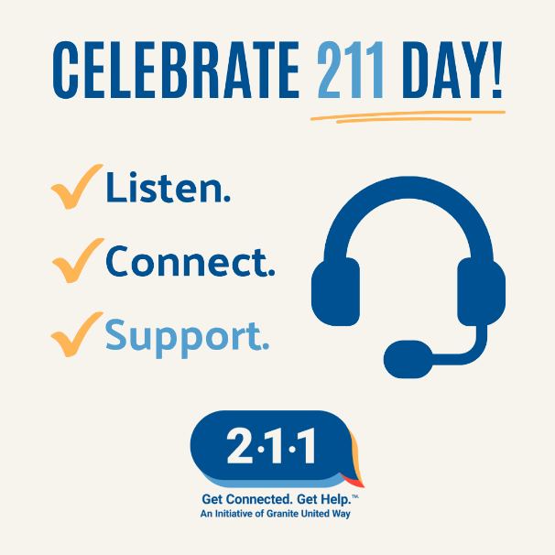
This 211 Day, take a moment to learn more about the many ways 211 New Hampshire can help.  From connecting people with housing resources to helping people find pet food pantries, 211 helps people access information, resources, and support for a wide range of needs.  Need help or know someone who does? Start with 211.  #211Day #211NH #GetConnectedGetHelp | 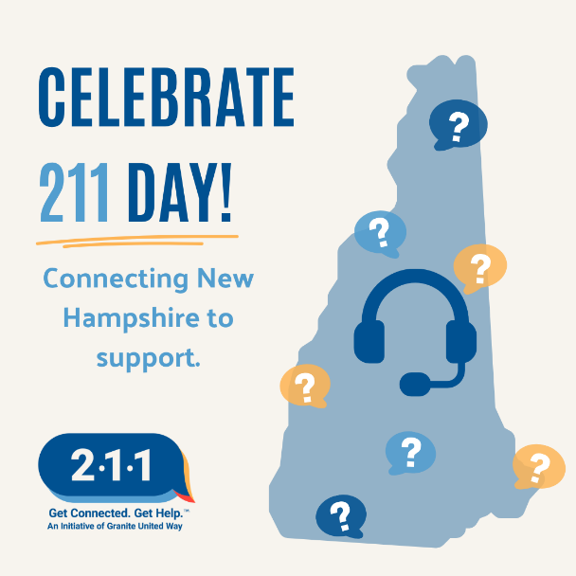
One of the most important things to know this 211 Day? You don't have to know exactly what you need before reaching out.  The trained information and referral specialists at 211 will listen, help identify your needs, and connect you with available resources.  One conversation can make all the difference. Call 2-1-1 or visit 211nh.org.  #211Day #211NH #GetConnectedGetHelp | 